# Average, Median, Throughput, and Standard Deviation etc

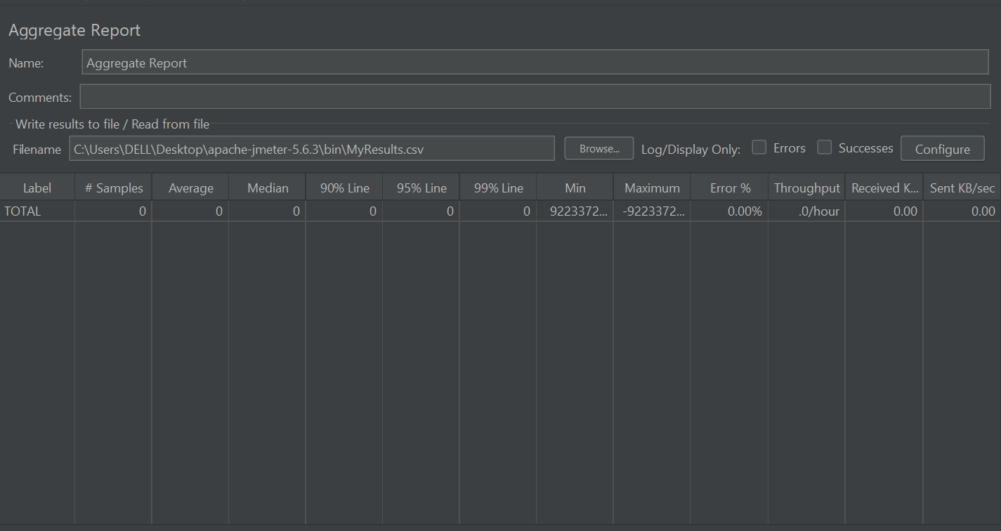

**🏷️ Label**

* **What it is:** Name of the sampler or transaction (e.g., "Login Request").
* **Why it matters:** Helps identify the specific user action or request.
* **Example:** Login, Search Product, Checkout, etc.

**🔢 #Samples**

* **What it is:** Number of times a request was executed.
* **Why it matters:** Shows the test volume for each sampler.
* **Example:** If 100 users each send 1 request to "Login", you'll see **100 samples**.

**📈 Average**

* **What it is:** Mean response time (Total Time ÷ Samples).
* **Unit:** Milliseconds (ms).
* **Why it matters:** General sense of how fast your request is.
* **Example:**
  + Total time = 3000 ms for 10 samples
  + Average = 300 ms

**📊 Median**

* **What it is:** 50th percentile—middle value in sorted list.
* **Unit:** Milliseconds (ms).
* **Why it matters:** Less impacted by outliers; reflects typical user experience.
* **Example:**  
  Times: 250, 270, 280, 290, 1000 → Median = 280

**🎯 90% Line**

* **What it is:** 90% of responses are faster than this value.
* **Why it matters:** SLA compliance. Common in performance benchmarks.
* **Example:**  
  SLA: "90% of responses should be < 2000 ms" → This column helps verify that.

**🎯 95% Line**

* **What it is:** 95% of responses fall below this time.
* **Why it matters:** Tighter SLA view—shows slower user edge.
* **Example:** If 5% users are seeing slowness, 95% Line will expose it.

**🎯 99% Line**

* **What it is:** Almost all (99%) response times fall below this.
* **Why it matters:** Highlights the worst-case scenarios users face.
* **Example:** Even if the average is low, a high 99% line can show latency spikes.

**⏱️ Min**

* **What it is:** Fastest response time observed.
* **Unit:** Milliseconds (ms).
* **Why it matters:** Shows best-case system performance.
* **Example:** A value of 110 ms might indicate a very quick cache hit.

**🐢 Max**

* **What it is:** Slowest response time observed.
* **Unit:** Milliseconds (ms).
* **Why it matters:** Useful for detecting **outliers** or **server hiccups**.
* **Example:** Max = 5000 ms when average is 300 ms → investigate!

**⚠️ Error %**

* **What it is:** Percentage of failed requests.
* **Formula:** (Number of Errors / Total Samples) * 100
* **Why it matters:** Indicates application stability and test accuracy.
* **Example:**
  + 10 errors out of 100 = **10% error rate**
  + Should ideally be **0%**

**📡 Throughput**

* **What it is:** How many requests per second (or per time unit).
* **Unit:** Requests/sec (can also be per min/hour).
* **Why it matters:** Shows system capacity and concurrency handling.
* **Example:**
  + 300 requests over 10 seconds = **30 requests/sec**

**⬇️ Received KB/sec**

* **What it is:** Data **received** from the server per second.
* **Unit:** Kilobytes per second (KB/sec).
* **Why it matters:** Measures **network bandwidth usage**.
* **Example:** A value of 2000 KB/sec implies high-volume responses (images, JSON, etc.)

**⬆️ Sent KB/sec**

* **What it is:** Data **sent** to the server per second.
* **Unit:** Kilobytes per second (KB/sec).
* **Why it matters:** Useful when you're uploading files or sending large payloads.
* **Example:** Uploading 10MB files will reflect in a high Sent KB/sec.